No. of Pages | 4
No. of Questions | 8

Department of Computer Science and Engineering
FINAL EXAMINATION FALL 2008

CSE320: Data Communication
Total Marks: 90 Time Allowed: 3 Hours

- Answer any Six (6) questions out of the given Eight (8) questions.
- Figure in bracket [] next to each question indicates marks for that question.

Question No. 1

- Name the layers of the TCP/IP model along with their associate PDU names and the addresses used. [4 marks]
- Compare Port numbers, MAC addresses and IP addresses. [4.5 marks]
- Fill up the blank spaces in the PDUs with appropriate addresses in the diagram given separately. Alphabets represent MAC addresses and numbers represent IP addresses. [4 marks]
- What does ISO refer to? Why is it essential for the communication process? [2.5 marks]

Question No. 2

- Give examples of applications, services and protocols being used when you try to browse a webpage. [3 marks]
- Compare the DNS and FTP protocols of the application layer. [4 marks]
- How does DHCP make a network more efficient, specially a large network? In which type of hosts you will not use DHCP, and why? [ 4 marks]
- POP and SMTP are protocols of which application/s? Briefly explain their functions. [4 marks]

Question No. 3

- Give examples of applications that use only TCP and only UDP? How do applications choose between TCP and UDP? [4 marks]
- Transport Layer uses port numbers to identify what? What are the different port numbers available? Give examples of any one. [3 marks]
- List some functions of the Transport Layer. [2 marks]

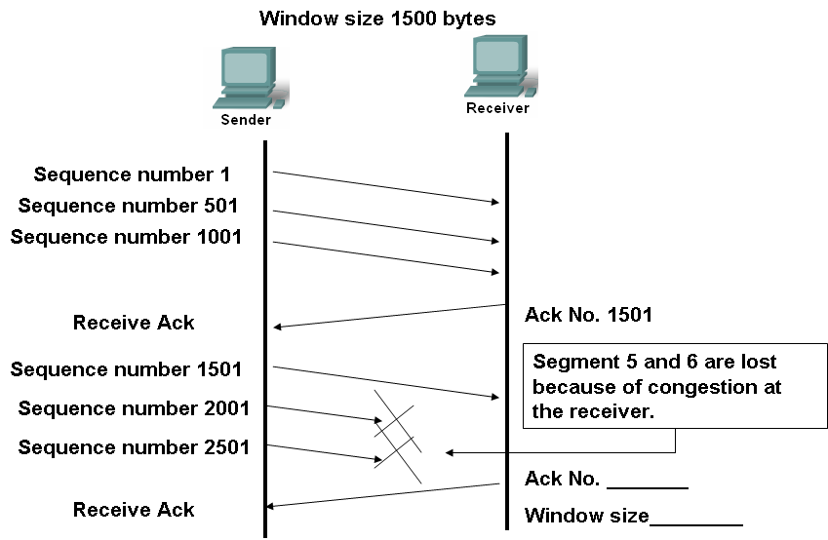
Figure No. 1
- Refer to the figure no. 1, what is the purpose of the fields, Sequence and Acknowledgement numbers and Window size? Fill the blanks in the figure appropriately. [6 marks]

Question No. 4

- List some of the characteristics of IPv4. Briefly explain any one. [3 marks]
- Which fields in the IP PDU header allows the router to forward packets and to prevent endless looping? [2 marks]
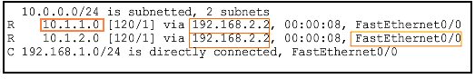
Figure No. 2
- The above figure no. 2 is a routing table of a router. What will the router do when it receives a packet destined for 198.162.20.0 network and another packet destined for 10.1.2.0 network? [4 marks]
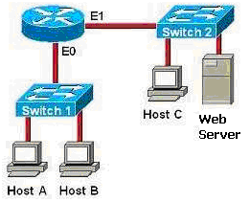
Figure No. 3
- For the above figure no. 3, how many broadcast domains and collision domains are there? [2 marks]
- Refer to the figure no. 3, which interface’s IP address will act as its default gateway for host C? Explain the purpose of a default gateway. [4 marks]

Question No. 5

- What is the purpose of subnet mask? What is the difference between “/26” notation and “255.255.255.192” notation? [3 marks]
- Scenario for the above figure no.4:
  - Address space: 192.168.15.64/26
  - RTA, 14 hosts and 6 hosts; RTC 5 hosts.
  - Assign subnets to the topology as required.
  - Fill in the table given separately with all necessary IP address configuration information for all devices. [12 marks]

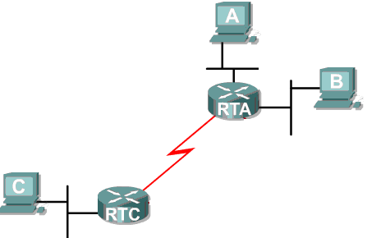
Figure No. 4
16 Hosts
6 Hosts
5 Hosts
Fa 0
Fa 1
Fa 0
S 0
S 0

Question No. 6

- Is the purpose of Scrambling and Block Coding the same? Yes or no, explain briefly. Compare both processes and give examples. [4 marks]
- Encode the following data to Differential Manchester and MLT-3 encoding techniques? [3 marks] 100111100010
- “Manchester Encoding scheme is very different from all the other schemes”, explain the statement. [2 marks]
- Twisting reduces cross talk interference, so why do we only twist Twisted Pair cables but not Coaxial Cables? [3 marks]
- You are required to set up a network in an organization where the distance between equipments is more than 150 meters and they are exposed to a lot of electrical interferences, and the company do not have much fund to invest either, which type of cable would meet all of these requirements and why? [3 marks]

Question No. 7

- Compare the characteristics of Go Back N ARQ and Selective Repeat ARQ. [4 marks]
- In Selective Repeat ARQ, explain what will happen after a Negative Acknowledgement (NAK) for a particular frame is lost during transmission. [4 marks]

- Draw the structure of a supervisory frame of HDLC. What is the difference between the REJ and SREJ code bits of a supervisory frame? [4 marks]
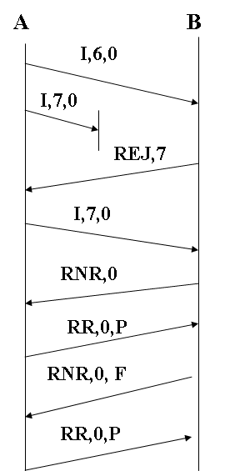
Figure No. 5
- For the above figure no. 5 what is the purpose of the P and F letters shown in the last three frames? [3 marks]

Question No. 8

- What happens when a host connected to a hub detects a collision in CSMA/CD? [3 marks]
- Suppose there is heavy traffic on both a CSMA/CD LAN and a Token Ring LAN. On which system is a station/host more likely to wait? Give reasons for your answer. [3 marks]

Preamble  8 bytes | Destination  Address | Source  Address | Type | Data | Frame Check Sequence  4 bytes
Figure No. 6

- The above figure no. 6 represents an Ethernet LAN frame; the last four bytes of the frame contains bits using CRC method. Explain. State what happens at the sender side in CRC method. [4 marks]
- What happens when a token is destroyed in a Token Ring LAN? [2 marks]
- Compare 10BASE-5 and 100BASE-T in terms of connectors, transmission media and data rate. [3 marks]

THE END

